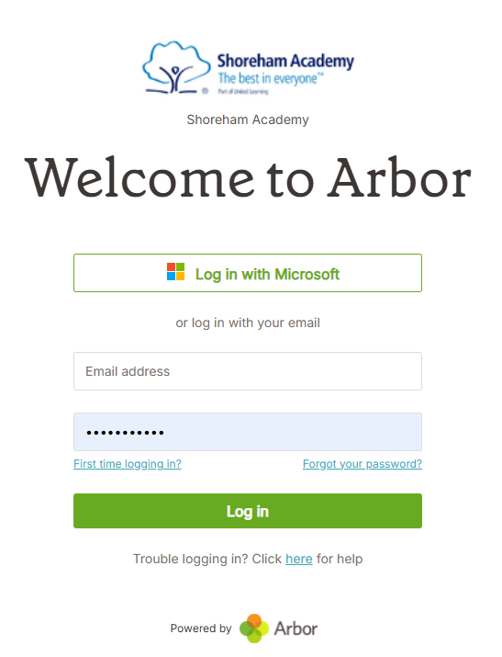
If you forget your password reset it here In’
Click ‘First Time logging In’
Enter your email address in the popup box and click ‘Set Password’
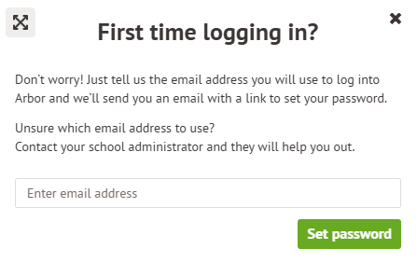
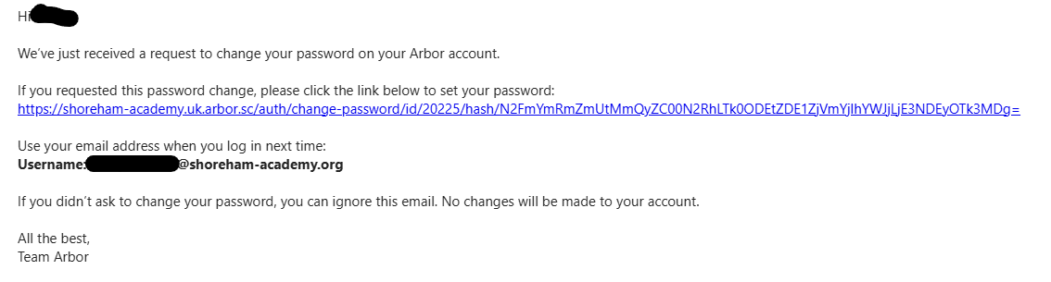
Go to your school email and click on the link and set your password.

